CITY OF BARTOW, FLORIDA

TO: City Commission
FROM: Mike Herr, City Manager
DATE: July 26, 2024
SUBJECT: City of Bartow Aquatics Program

SUMMARY
The City of Bartow City Commission has been actively planning for the reinstatement of a municipal pool and Aquatics Program for the last eighteen months. The Commission is currently weighing the best location for the site of the aquatics program that will most optimally serve the community as a whole. Additionally, we are assessing the ideal programming and amenity options. The site for the aquatics center should be based on economics, potential development opportunities and the quality of life potential of each location and their surrounding areas. The purpose of this briefing sheet is to outline the factors to be considered in making the final decision including an analysis of the economics and development potential of each site, community feedback and funding.
BACKGROUND
The city has a long history of providing a pool to the community, having had pools located at the former Civic Center, now known as the Oaks Building, the Carver Recreation Center and the current Civic Center located at 2250 S. Floral Ave. Each pool the city built had a modern design and function for its time. With that said, conversations still exist based on a divide in the community which stems from access to the pools of the past as well as closures that prohibited use for many segments of the population.
The next pool the City of Bartow builds has to be for everyone. It must be a bridge building opportunity that links the community together and helps to spur the future desired by our stakeholders. For more than a decade development was slow in Bartow, but that has changed as growth has begun to materialize. Now a community that largely lay dormant for a decade, can begin to strategically plan the development we wish to have in order to maintain the charm of our community while welcoming progress. It is important to be intentional about the decisions we make that will yield positive outcome-based results.
It is also important to consider the economics of the situation. A good aquatics program should drive economics to the surrounding area. To add to that as the county seat, we have a guaranteed number of government workers that come to town each business day adding to the busyness of our community. These are potential stakeholders as future residents to our charming city.
While the previous administrations thought it best to save dollars rather than invest in infrastructure, it is not possible to ignore the fact that we have significant capital improvement needs that have to be addressed. I have requested the City Commission approve a spend down $15.5 Million of General Fund reserves to address the most crucial infrastructure needs. This includes the pool in addition to moving our Public Works facilities, a new joint Fire Substation with Polk County and $3.3 Million in park improvements. It will take ingenuity and creative budgeting to ensure we can build these projects to a standard that can last 50 years within the funding that is available.
As evidenced by the community response to this initiative, teaching Bartow residents to swim and providing an aquatic amenity is an important outcome for our community. The current pool was constructed in 1967 and has been closed for several years since Covid due to operational issues. That pool was built prior to current standards for both disability compliance as well as competition standards and does not meet today’s requirements for the city’s aquatics program.
As a very large pool, the current pool is extremely expensive to maintain, heat and provide chemicals to ensure the health and safety of all patrons. The City Commission has unanimously decided to provide a more modern facility that has a “wow” factor for residents and visitors. The pool that has initially been designed will provide water entertainment features as well as be fully ADA compliant. It is important to note that the programming area of this newly envisioned pool provides the optimum space for activities in the form of swim lessons and exercise programs.
While a competition pool is a nice feature to have for a community, the City of Bartow can not financially support the construction and maintenance of two pools. We are focusing on the greatest need for the community as a whole which comes in meeting our primary goals:
- Teach children within our community to swim with year-round learn-to-swim programs
- Provide families with a water entertainment amenity
- Establish an aquatics program for all ages to include activities like water aerobics and wellness programs
- Offer a training option for local swimmers
It is also worth noting that providing a venue for students of the Polk County school system is ultimately the responsibility of the School Board. The city could be amenable to a partnership for the construction and maintenance of a competition pool to serve this need, but the school board has not expressed interest in that option at this time. My emphasis here is this option is too expensive for the City of Bartow to fund.
LOCATIONS
The two locations under consideration for location of the municipal pool are:
- The Oaks Building located at 455 N. Wilson Ave.
- The Civic Center located at 2250 S. Floral Ave.
Below represents the number of households within a two mile radius of each location. There are 7,770 residences within a 2 mile radius of the Oaks Building and there are 5,533 residences within a 2 mile radius of the Civic Center.
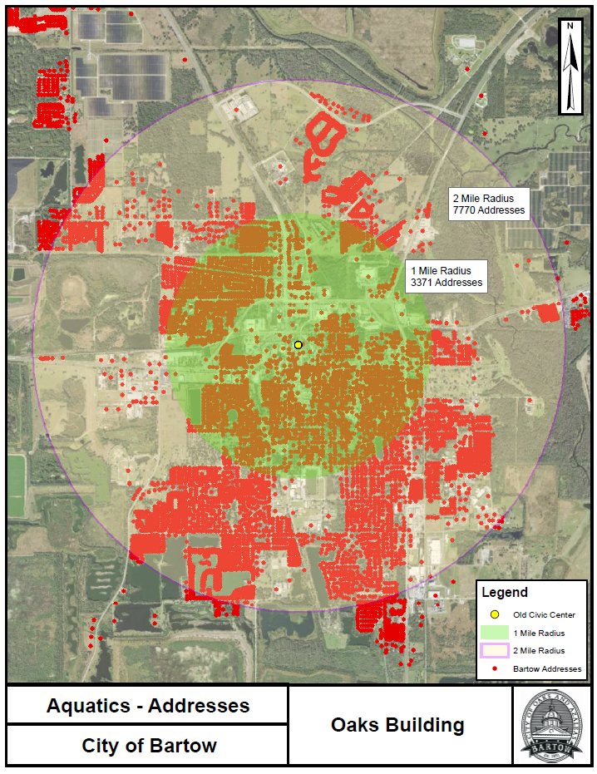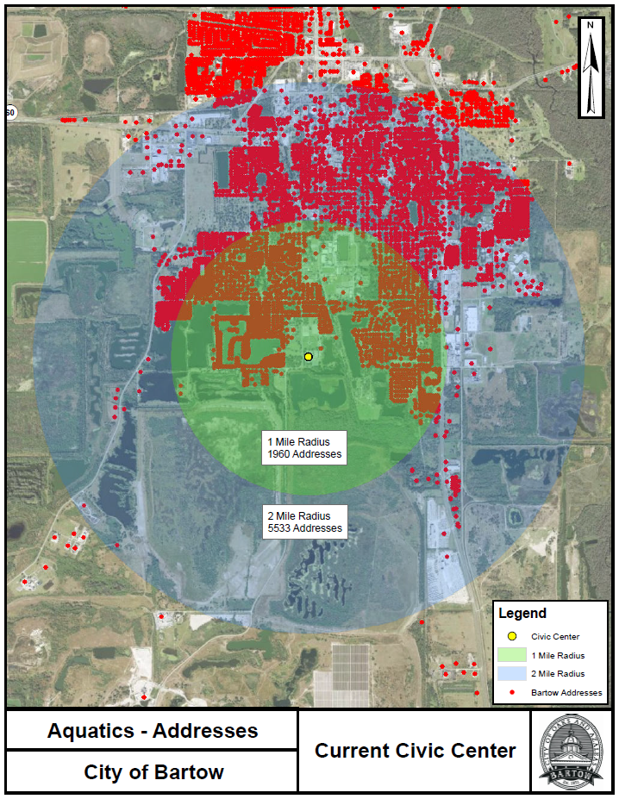
Oaks Building
The Oaks building is the site of a City Recreation Center built in the 1930s and now sits vacant. This proposed concept aims to revitalize this locally significant site into a state-of-the-art community hub for recreation and wellness by creating a new aquatics facility. The proposed Aquatics Center would honor the site’s multifaceted history, from its New Deal origins to its educational and civic roles. Admission fees would be required.
The Oaks Building lies within the City of Bartow Community Redevelopment District which creates different evaluation elements. The City of Bartow Community Redevelopment Agency (CRA) is a public entity that was created to implement redevelopment activities in a defined area as outlined under Chapter 163, Part III of the Florida Statutes the Community Redevelopment Act.
The City of Bartow CRA is a dependent tax district that has dedicated funding for the purpose of:
  - Reducing or eliminating blight
  - Improving the economic health of the district
  - Encouraging public and private investments in a CRA district
By using the Oaks location, we can potentially leverage resources and help the CRA achieve its mission of “Elevating Bartow by transforming our CRA district by encouraging investment that enhances our neighborhoods and drives economic growth while preserving our diverse history.” Additionally, we can work together to address the CRA’s adopted two year goals that include:

2024-2026 CRA Goals Include:
  - Increase awareness of the CRA district as a destination point – residents, employees, visitors and developers
  - Retain current businesses and attract new businesses in the CRA district
  - Develop initiatives or programs for revitalization in the downtown and the east, west, and North CRA areas

As a property within the CRA district, there is the potential for CRA funding to be used to offset construction costs for such things as streetscape and landscaping around the Oaks Building, parking, and the renovation of the existing building for purposes of economic development. Additionally, slowing traffic in downtown is an important element regardless of whether the aquatics center is located at the Oaks Building that this project can support. The CRA can play a pivotal role in designing and executing a transportation plan that encourages smart design in addition to pedestrian friendly streets.
Possibly most important in weighing this location is the redevelopment possibilities the Oaks Building provides as a catalyst for further development in and around the site. The city fully recognizes that our facilities directly adjacent to the Oaks Building including the Police Station, Fire Station and Information Technology buildings all need to be replaced. With that in mind, we should evaluate the future development potential of the city block since the city will have to vacate these structures within the next 5-10 years at the latest. It is important to consider how this project can be leveraged to appeal to potential developers and possibly work to provide additional revenue streams in the form of ad valorem tax revenue and impact fees. If the city no longer occupies portions of the area, those dollars will translate to ad valorem taxes helping to build the tax increment funding to the CRA for partnering with redevelopment opportunities.
There is also the linkage to downtown businesses that can be supported through this concept. The intention would be to offer “Taste of Bartow” opportunities for our local eateries and shops to utilize complimentary space that can be frequented by both patrons of the pool and local foot traffic from surrounding professional offices.
No contingency plans are in place at this time if the Oaks Building is not selected as the Aquatics location. Further plans will have to be developed based on all economic and development factors.
Civic Center
The proposed concept of replacing the current pool at the Bartow Civic Center aims to remove the existing pool and replace it with the Aquatic Center Design. The Bartow Civic Center was originally envisioned as a community conference center. Over time the campus has evolved to provide various sporting options including soccer, football, and tennis.

When considering the Civic Center location, we need to evaluate the best use of the building for the next 25 years. For instance, perhaps it is more ideal to turn the Civic Center campus into a sports venue rather than meeting space based on what amenities are currently offered at the campus. With that said this design does not include concessions and an alternative plan for servicing patrons would be necessary (ie. food truck). On the plus side the existing locker rooms/restrooms could be utilized for the aquatics center but will likely need renovation. Admission fees would be required at this venue.

It is also important to note that the outdoor pavilion and recreation lawn concept is only feasible at the Civic Center as a replacement of the existing pool’s footprint. That particular economic driver would be removed from our plans if the aquatics center is located at the Civic Center.

If the Civic Center is meant to remain as meeting space for professional use or large events, creating an aquatics program that matches that use will need to be part of the project planning.
As a reminder, current investments underway at the Civic Center include:
- Part of parks overall infrastructure enhancements in the City’s Capital Plan:
  - Construction of 8 lit tennis courts
  - Remodel of Civic Center kitchen
  - Baseball field lighting
  - New baseball field scoreboard
  - 2 new soccer fields
  - Removal of shuffleboard courts and basketball court

COMMUNITY FEEDBACK
To provide insight into the decision on location, amenities and programming, the city conducted a survey which ran from June 24 to July 19. There were 962 surveys collected and validated for this project. The survey was not anonymous, however if a name was provided without an address, we included the survey results. Of the 962 survey respondents, 773 were submitted electronically and 190 were submitted and processed in paper form. It is also worth noting that 56 campers in our summer camp program completed the survey. You can view the entire survey results in Attachment A: City of Bartow Community Survey Results that includes all open-ended comments.
Of the 962 survey respondents, 930 approved with our initiative to construct a pool equaling 97%. Thirty-two respondents answered this question with either a no or not sure equaling 3%.
There was a good distribution of age groups that participated in the survey with the largest segment being 35-44.
Under 18 | 68 | 7%
18-24 | 37 | 4%
25-34 | 196 | 20%
35-44 | 255 | 27%
45-54 | 139 | 14%
55-64 | 122 | 13%
65+ | 145 | 15%
TOTAL | 962

There were 681 residents who completed the survey and 19 business owners. There were 52 respondents who designated themselves as residents and business owners, and there were 36 respondents who selected not applicable to this question. In most instances these are people who completed the survey but live outside the city limits.

Following are heat maps to represent locations of respondents:
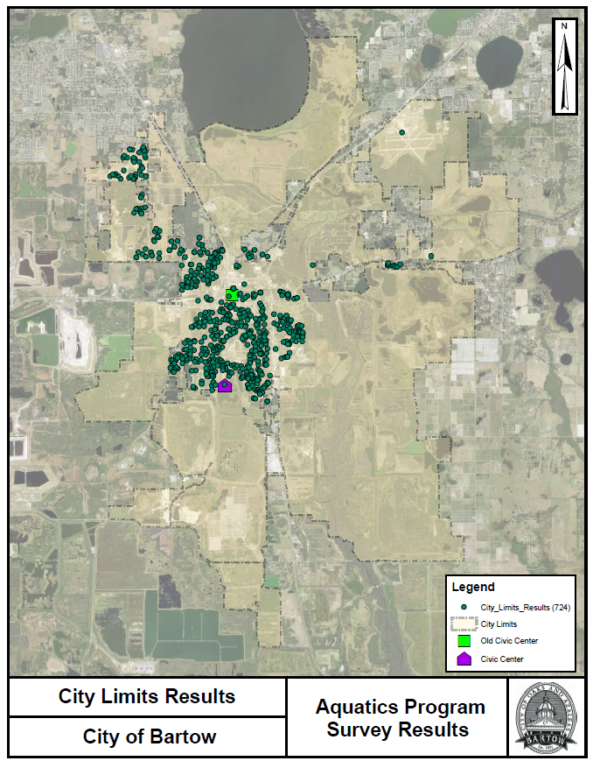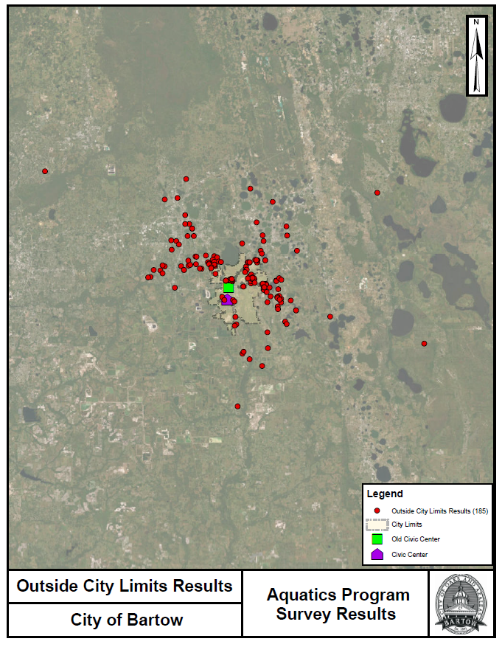
Of the respondents 617 selected the current Civic Center as the location for the new pool and aquatics program and 310 selected the Oaks Building in downtown. Thirty-five respondents answered this question by selecting other and in some cases providing open ended comments.

Below is the heat map representing site location selections:
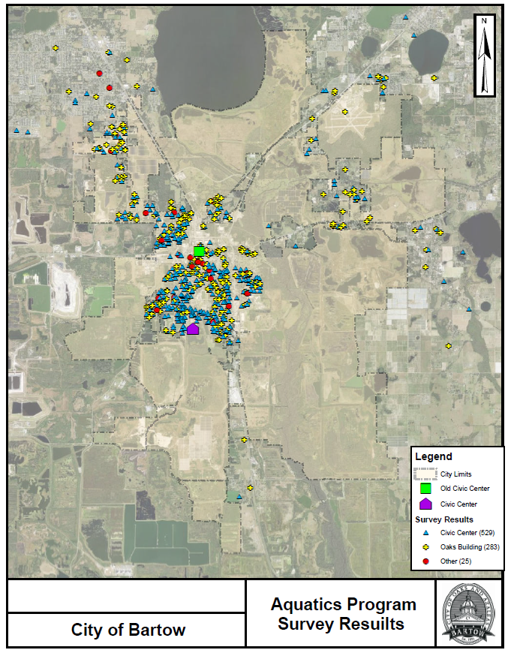
Constructing a pool that is equipped for swimming lessons and exercising received the highest ranking on the amenities question at 85% of respondents. Providing a children’s pool (73%) and splash pads (64%) were the next highest rated amenities. Following is a breakdown of all rated amenities.

Respondents were asked to provide feedback on potential locations for splash pads in the community. Mary Holland Park was selected by 689 respondents, while Carver Recreation Center received 376 and Polk Street Community Center received 230.

Swim lessons were the top selection in the programming category with 67% of respondents. Party rentals were next with 49% of respondents.

In addition to feedback received through the survey, the city also held a community meeting on July 11th. During this meeting citizens voiced their concerns and provided feedback on the locations. The majority of comments favored the Civic Center as the location of the pool. Additional comments have been received via the City’s social media.
Lastly, the following was received by Suzannah Albritton. Since this engagement was not captured either via the survey instrument or the community meeting, the entirety of message is offered here.

I’d like to voice my opinion on the location choice and why.

First the Civic Center:
- The existing pool is not being repaired.
- The locker/dressing rooms are not in good shape
- This location has become more of a sports center for soccer and softball and venue for meetings and city/holiday events.
- Turning the back area into an outdoor venue space could open up and extend the existing indoor area for larger events.
- When there are events and or games or practices going on then parking would be more limited.
- This location is not centrally located in the city limits

Now the Oaks Location:
- This location is centrally located
- People using this location would be more apt to visit and patronize downtown merchants and restaurants.
- This would be exclusively be THE aquatic center building
- There would be more than adequate parking adjacent to and across the street with a four way intersection
- Bartow would finally be restoring and refurbishing one of it’s historic buildings and putting it to good use instead of letting it fall into further disrepair
- This location would have all new locker/dressing rooms
- There is CRA funding available to help refurbish THIS building
- If we use this location we would gain using the Oaks building again AND we could gain an awesome outdoor venue at the Civic Center

Both locations would have the exact same sized pool.
Splash pads/ play areas also would be at both locations

Also I’m for putting the 2 splash pads at
- Carver Rec - especially since they lost their swimming pool years ago
- Mary Holland Park - because it is used and enjoyed by more kids/larger location

Thank you,
Suzannah Albritton
650 E Stuart St
64 yr Lifelong Bartow resident

PS: After listening to tonight’s meeting it sounds like the Civic Center supporters want it back as a competition pool. IF that happens I’m all for it being at the Civic Center. But if it stays the same pool at either location I’m sticking with the Oaks location as THE Aquatic Center to avoid the issues of parking and crowds from the other ongoing events at the Civic Center. A stand alone aquatic center would be a lot nicer and less stressful.

FUNDING
Below is the estimated funding per project. As previously stated, the potential exists to leverage CRA funding if the Oaks Building location is selected. This would focus on the streetscape and traffic calming, parking, and the economic portions of the building. All other funds for any of these projects would come from reserves. Operating expenses for the aquatics program will come from the General Fund in future years.
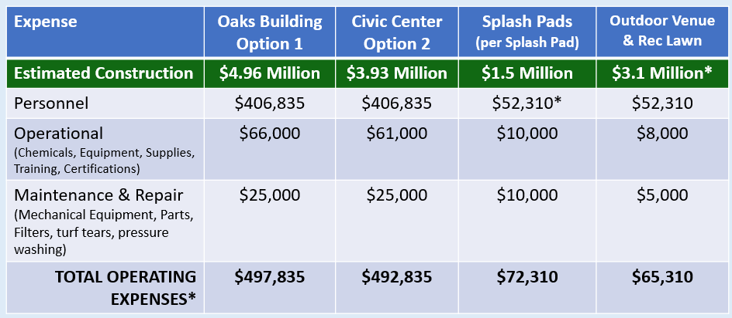
CONCLUSION
In reading the comments from the community survey, you can see the excitement at the idea of the City providing an aquatics program once again. It demonstrates the desire of the City Commission and City leadership to address health and safety as well as quality of life in our community. When weighing the economic and development factors along with the balance of quality of life desires, we can restore a sense of pride and enthusiasm in our City with our new municipal pool and aquatics program.
ATTACHMENTS
- City of Bartow Community Survey Results
- July 26 Aquatics Program Presentation

