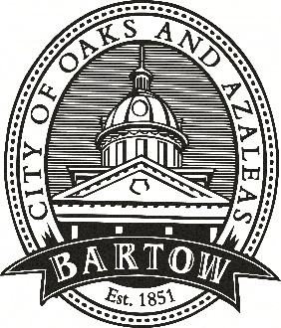
CITY OF BARTOW
450 N Wilson Ave.
Bartow, FL 33830
CityofBartow.net

PRESS RELEASE
For immediate release
Contact: Laurie Hayes, Director of Communications
City of Bartow
lhayes@cityofbartow.net
Office: 863.534.0100, ext. 1205
Cell: 863.378.7929

Bartow City Manager Mike Herr appointed to Florida League of Cities Committees
Groups Advocate for Florida Cities on a State and National Level

(October 5, 2023 – Bartow, FL) Bartow City Manager Mike Herr has been appointed to the Florida League of Cities’ 2023-2024 Advocacy Committee and its Federal Actions Strike Team (FAST). These two groups work to further the League’s influence in advocating for all of Florida’s cities and promoting local self-government to state and federal officials.
“I am honored to join the officers and members of these two important groups to further the goals of the Florida League of Cities,” said Herr. “Not only Bartow, but all 411 municipalities in the state of Florida benefit from these and other efforts of the League.”
Members of the Advocacy Committee are responsible for nurturing relationships with state elected officials and developing ideas and activities that strengthen the League’s legislative influence. The FAST committee is charged with establishing proactive and reactive communications with Florida's 30-member congressional delegation in support of federal municipal policy.
Herr, a long-time public servant, was hired as Bartow’s City Manager in January of this year. He previously served as City Manager in Winter Haven and Plant City as well as Polk County Manager, among other high level municipal positions.
The Florida League of Cities is the united voice for Florida’s municipal governments. Its goals are to serve the needs of Florida's cities and promote local self-government. Growing from a small number of municipalities that first gathered together in the 1920s, the League now represents more than 400 cities, towns and villages in the Sunshine State.
“I have long been a champion of Home Rule in the state,” noted Herr. “I look forward to working with our state and federal representatives to ensure that local self-government continues to thrive in Florida.”

###

